Project Report
Import Data using Transform Maps (Spreadsheet) – ServiceNow

Date | 30 September 2026
Team ID | SWTID-2026-9545
Project Name | Import Data using Transform Maps (Spreadsheet) – ServiceNow

1. INTRODUCTION
1.1 Project Overview
This micro project imports structured employee data from an external spreadsheet into the ServiceNow platform using Import Sets and Transform Maps. The spreadsheet is first loaded into an Import Set table that acts as a staging area. A Transform Map then maps source fields to the target table, records are created and validated, and duplicate handling is added with coalesce. Reports and a dashboard present the results.
1.2 Purpose
To help beginners understand the end-to-end import process in ServiceNow – data loading, field mapping, transformation, result verification, deduplication and reporting – using a real-world bulk employee data scenario.
2. IDEATION PHASE
2.1 Problem Statement
Administrators receive bulk employee data in Excel and need to load it accurately, without duplicates, and see the outcome. Manual entry is slow and repeated imports create duplicates (PS-1, PS-2).
2.2 Empathy Map Canvas
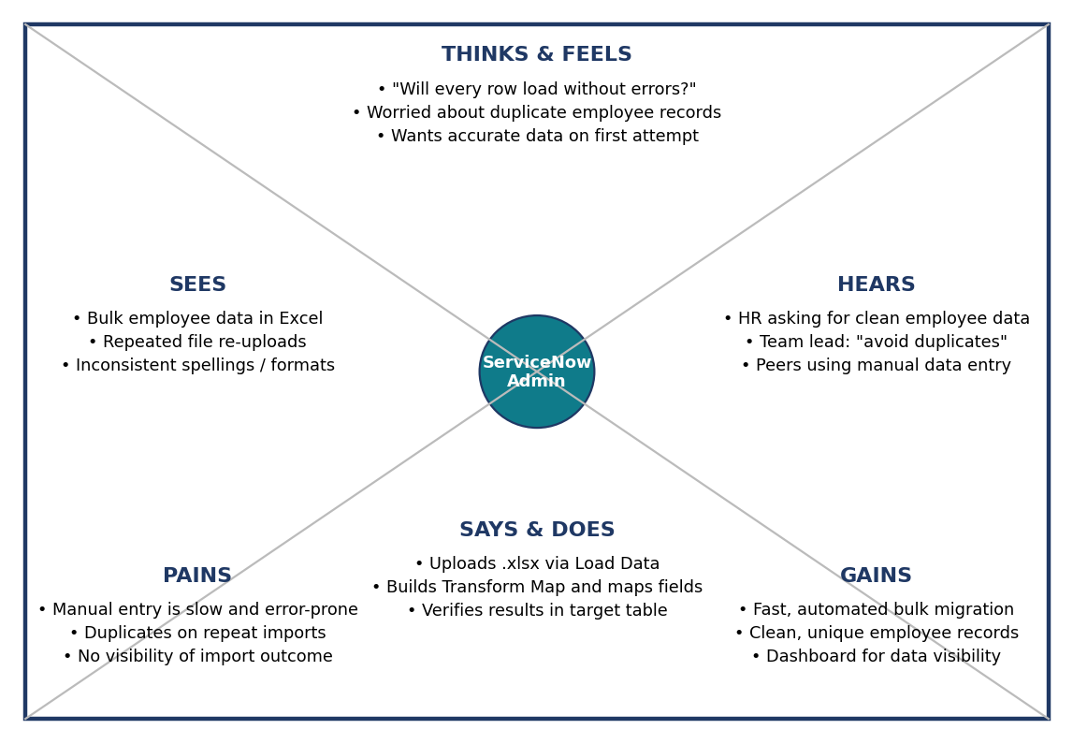
Figure 2.1: Empathy map
2.3 Brainstorming
Ideas were grouped into data entry, automated import, data quality and visibility. Import Set + Transform Map, Coalesce on Employee ID, three reports and a dashboard were selected; scheduled import was deferred.
3. REQUIREMENT ANALYSIS
3.1 Customer Journey map
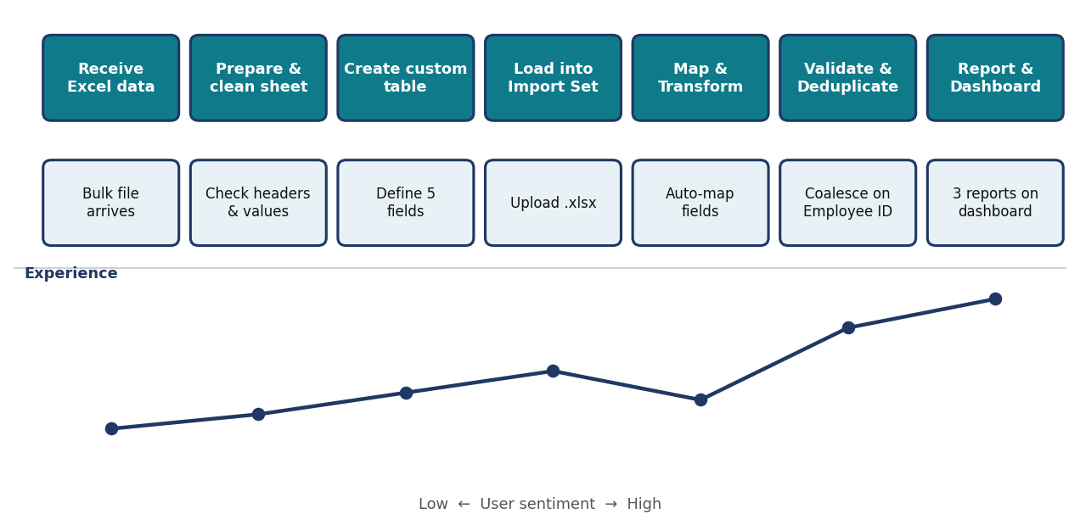
Figure 3.1: Customer journey map
3.2 Solution Requirement
Functional: data preparation, custom table, data loading, field mapping, transformation and validation, duplicate prevention, reporting, dashboard. Non-functional: usability, security, reliability, performance, availability and scalability (see the Solution Requirements document).
3.3 Data Flow Diagram
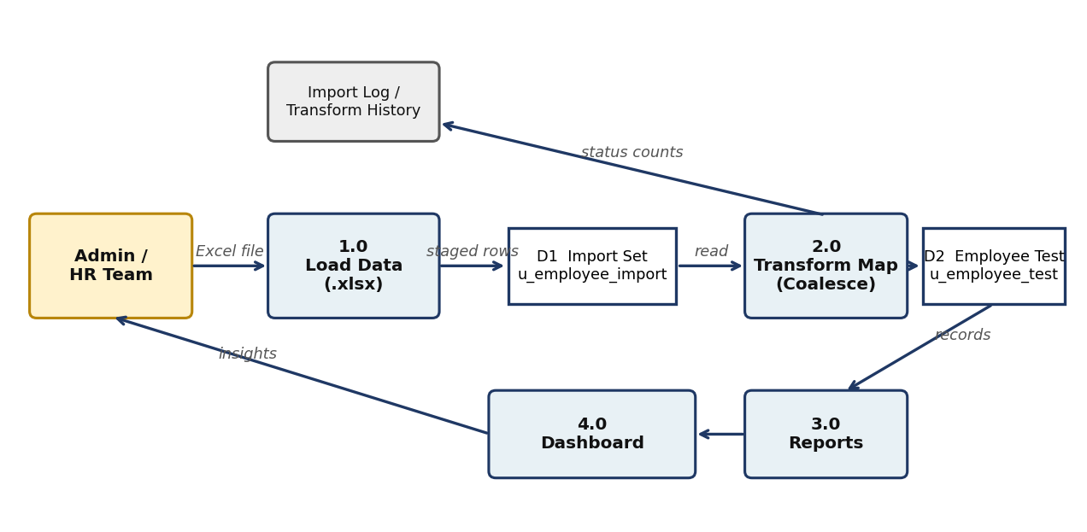
Figure 3.2: Data flow diagram
3.4 Technology Stack
ServiceNow platform (Import Sets, Transform Maps, Tables, ACL, Platform Analytics Reports and Dashboards) with Google Sheets used to prepare the .xlsx source file.
4. PROJECT DESIGN
4.1 Problem Solution Fit
Customer segment: ServiceNow administrators and HR data teams. The staged import with a coalesce key fits how they already receive data (Excel) and solves the duplicate and visibility problems.
4.2 Proposed Solution
Load spreadsheet to u_employee_import, transform to u_employee_test with five field maps, coalesce on Employee ID, then build Pie, Bar and List reports and one dashboard.
4.3 Solution Architecture
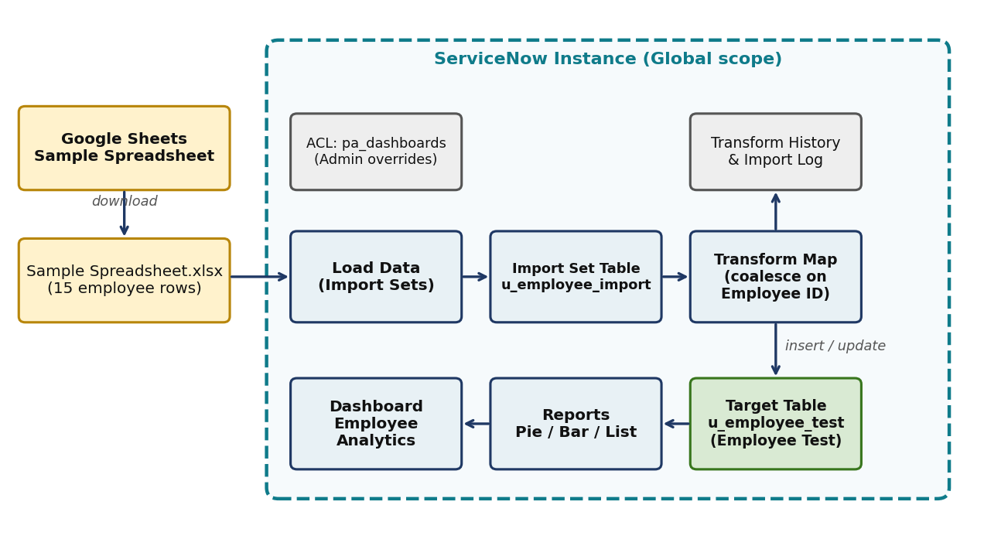
Figure 4.1: Solution architecture
5. PROJECT PLANNING & SCHEDULING
5.1 Project Planning
Sprint | Story Points | Duration | Start | Planned End | Completed | Release
Sprint-1 | 12 | 6 Days | 19 Jan 2026 | 24 Jan 2026 | 12 | 19 Jan 2026
Sprint-2 | 16 | 6 Days | 26 Jan 2026 | 31 Jan 2026 | 16 | 29 Jan 2026

Velocity = 28 story points ÷ 2 sprints = 14 story points per sprint.
6. FUNCTIONAL AND PERFORMANCE TESTING
6.1 Performance Testing
Test | Total | Inserts | Updates | Ignored | Errors | Result
Initial load and transform | 15 | 15 | 0 | 0 | 0 | Complete / Success
Re-import with changes | 4 | 2 | 2 | 0 | 0 | Complete / Success
Repeat of same file | 4 | 0 | 0 | 4 | 0 | Complete / Success

All 18 UAT test cases passed. Two low-severity data-quality observations remain open (lowercase “Servicenow” department value and the “Raviteja” name spelling).
7. RESULTS
7.1 Output Screenshots
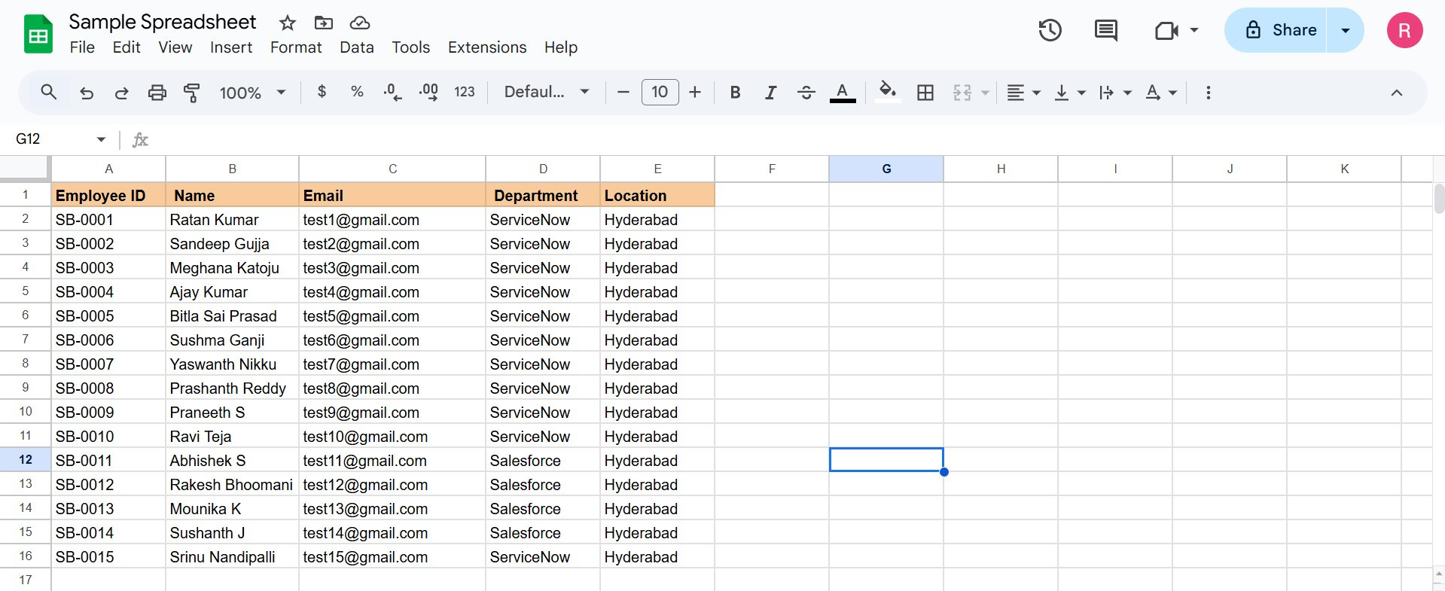
Figure 7.1: Source spreadsheet
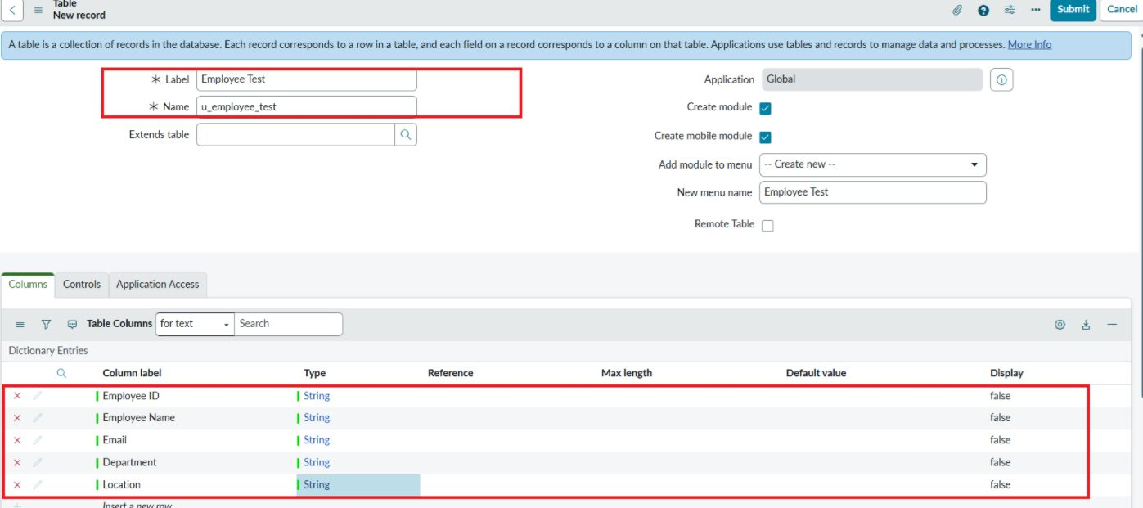
Figure 7.2: Custom table Employee Test with five columns
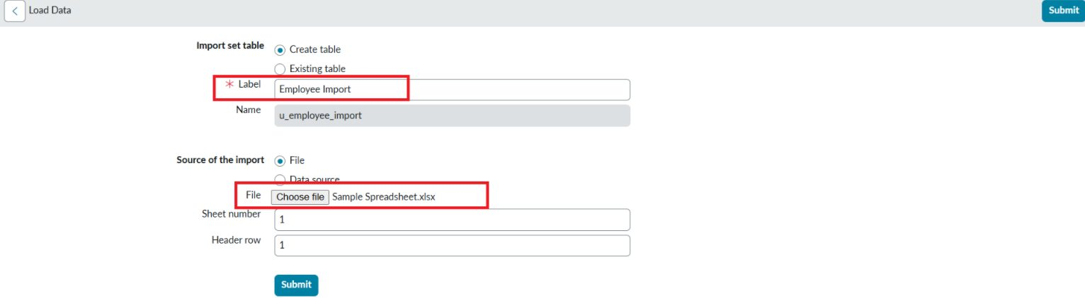
Figure 7.3: Load Data – creating the Employee Import table
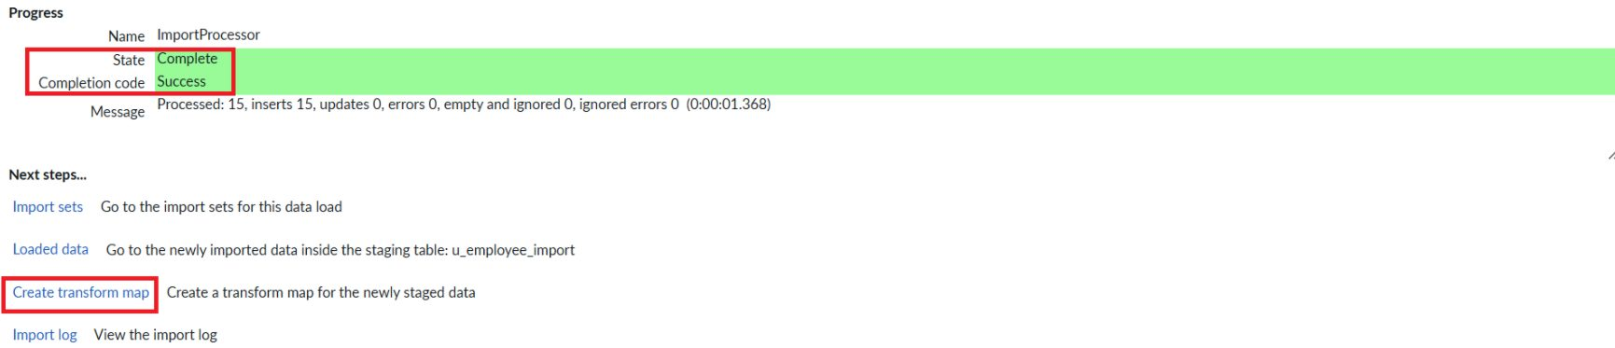
Figure 7.4: Import result – 15 inserted into the staging table
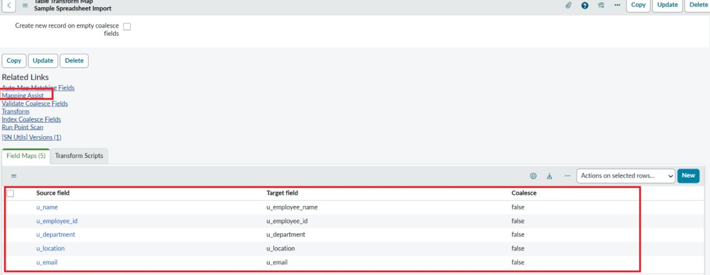
Figure 7.5: Transform Map field maps
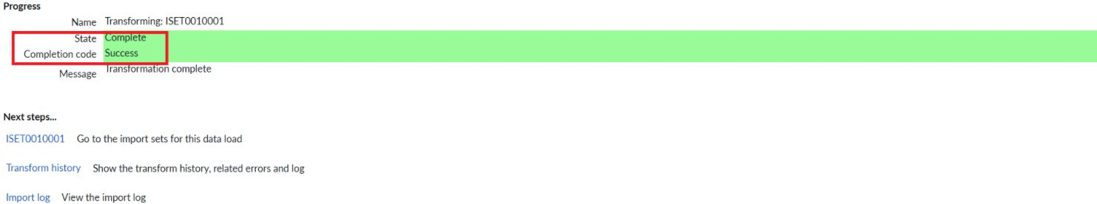
Figure 7.6: Transformation complete
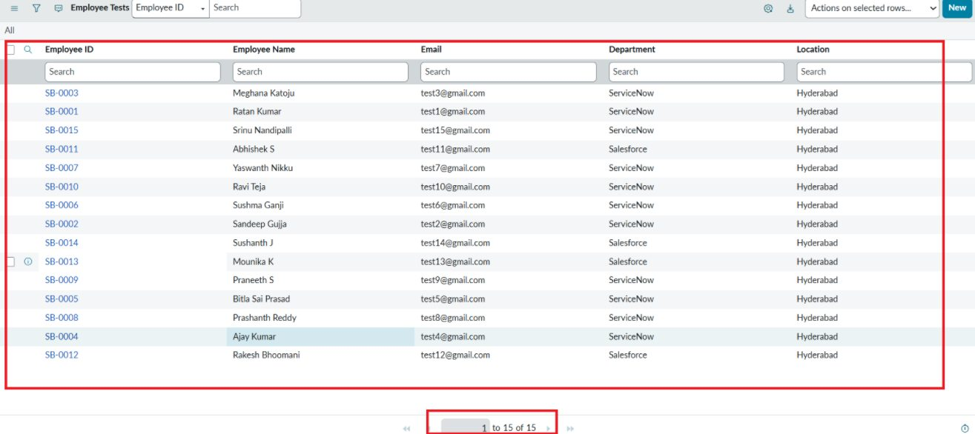
Figure 7.7: Employee Test records after the first transform (15 rows)
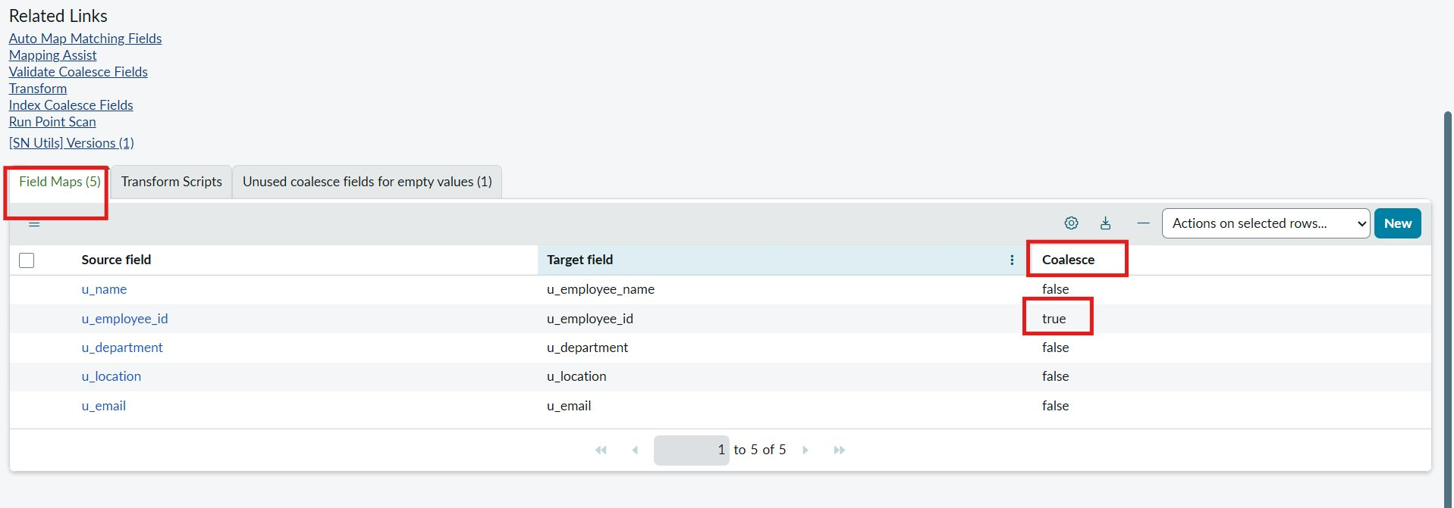
Figure 7.8: Coalesce set to true on Employee ID
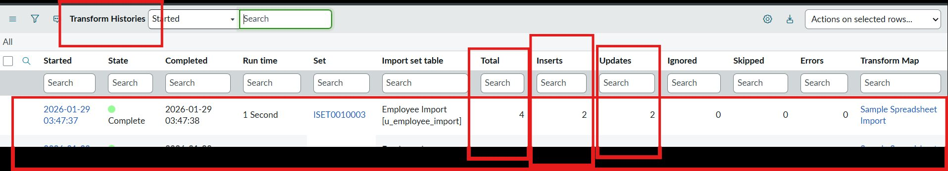
Figure 7.9: Transform history – 2 inserts and 2 updates
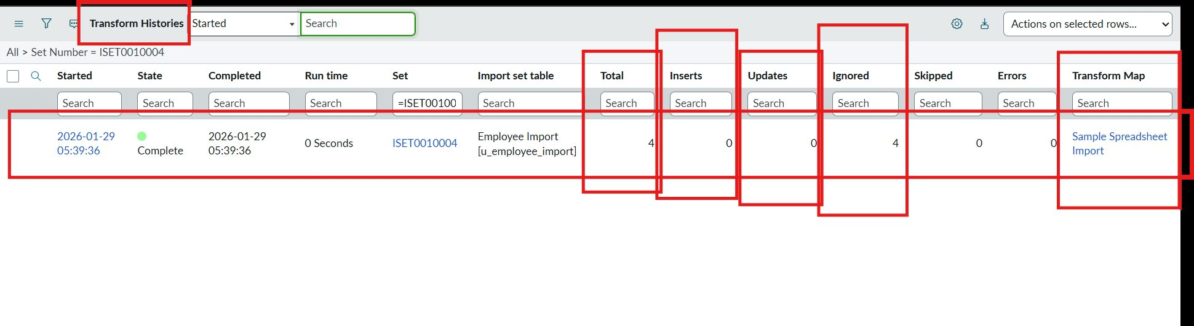
Figure 7.10: Repeat import – 4 ignored, no duplicates
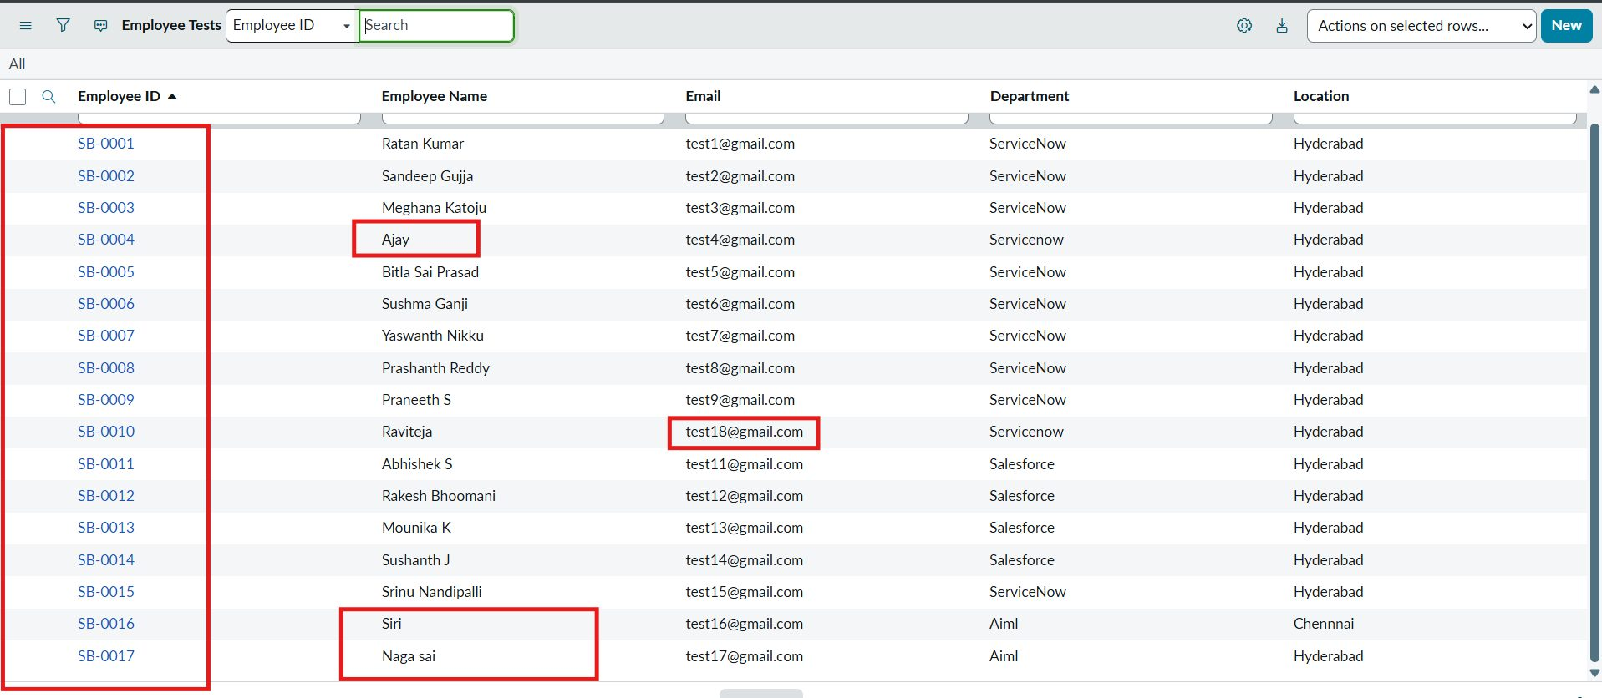
Figure 7.11: Employee Test table after updates (17 records)
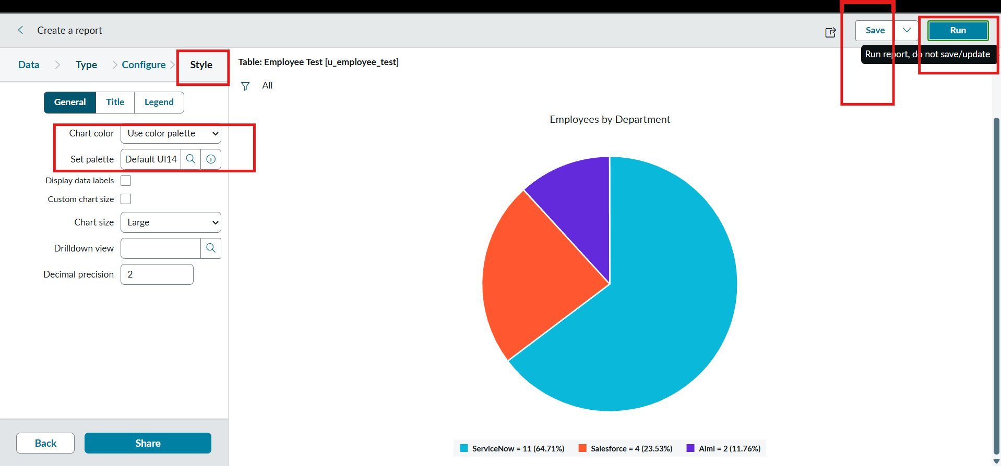
Figure 7.12: Report 1 – Employees by Department (Pie)
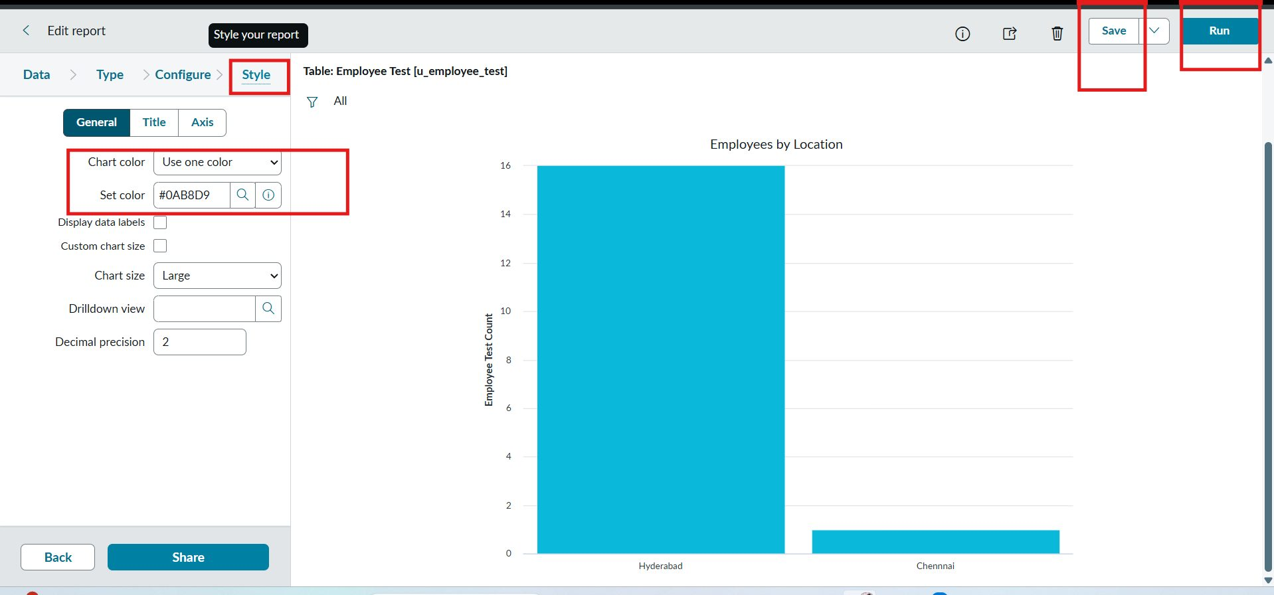
Figure 7.13: Report 2 – Employees by Location (Bar)
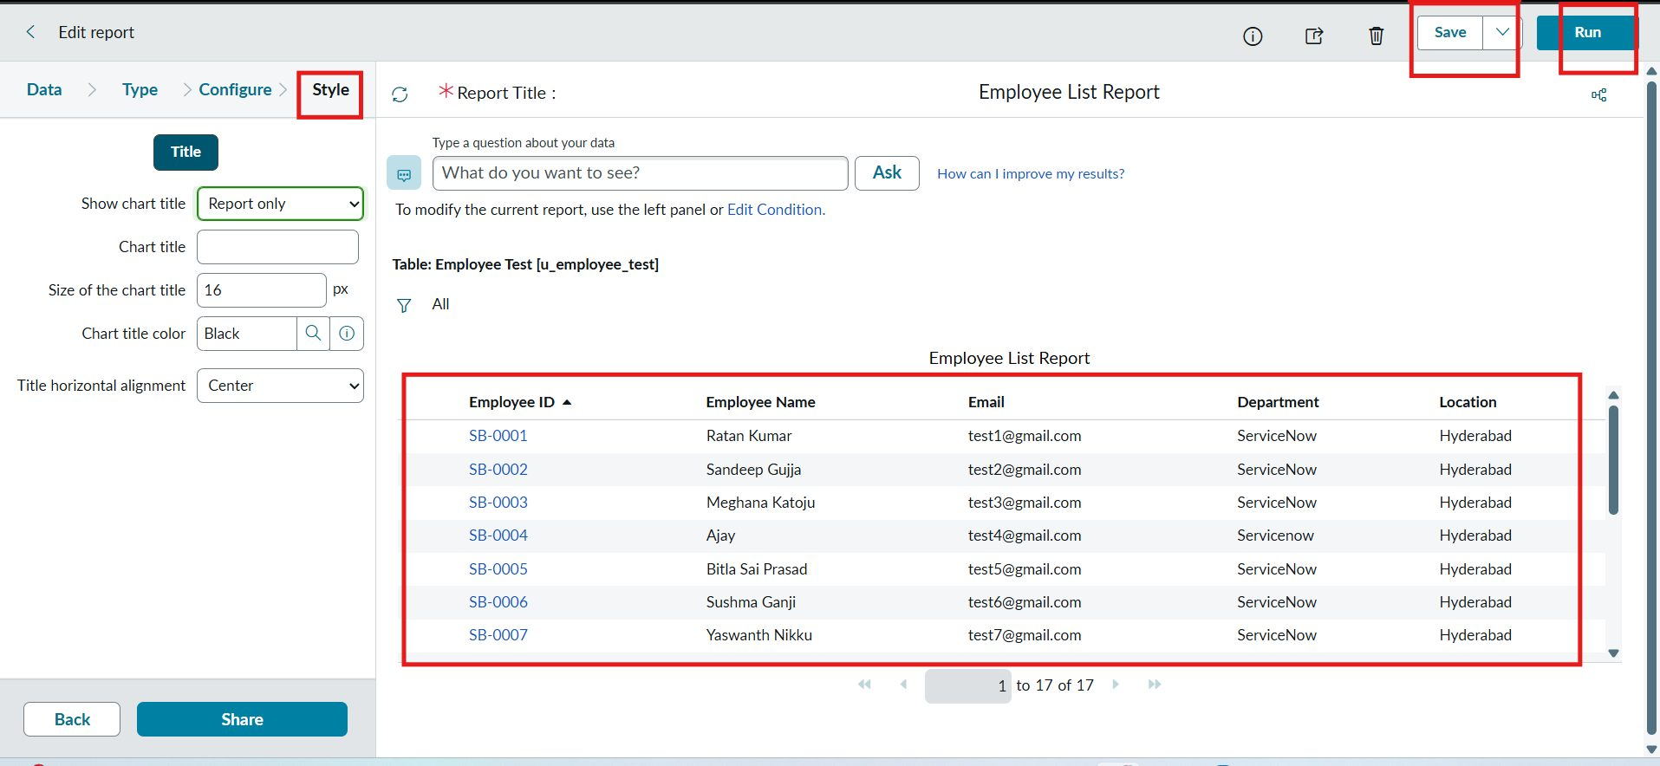
Figure 7.14: Report 3 – Employee List Report
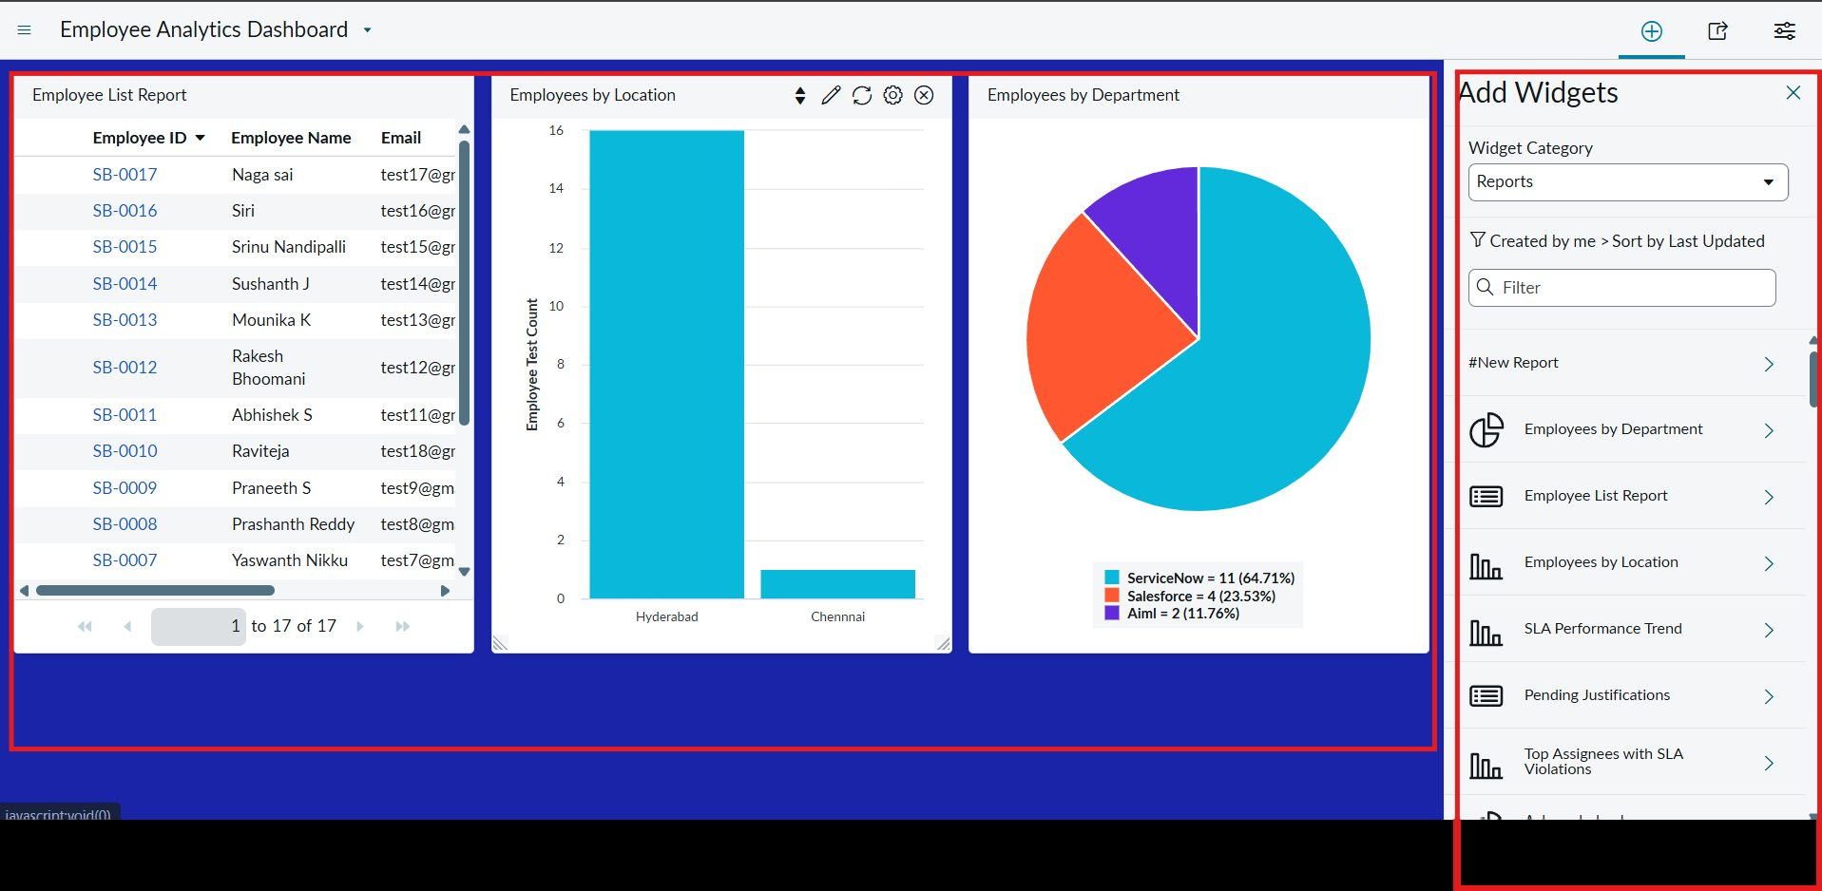
Figure 7.15: Employee Analytics Dashboard with three reports
8. ADVANTAGES & DISADVANTAGES
Advantages
- Fast, repeatable bulk loading instead of manual entry.
- Staging table separates raw data from the target table.
- Coalesce prevents duplicates and updates changed values.
- Dashboard gives one-view insight into the employee data.
Disadvantages
- Source data quality still matters (e.g. lowercase “Servicenow” was stored as typed).
- Coalesce on a single field means Employee ID must be unique and reliable.
- Import is manual (file upload); it is not scheduled or automated.
- Editing the pa_dashboards ACL requires admin rights and should be done only in a development or personal instance.
9. CONCLUSION
The project imported 15 employee records from a spreadsheet into ServiceNow with 0 errors, then demonstrated coalesce with 2 inserts and 2 updates, and 4 ignored rows on a repeat upload, leaving 17 unique records. Three reports (Employees by Department, Employees by Location, Employee List Report) were built and combined on the Employee Analytics Dashboard. Import outcomes (totals, inserts, updates, ignored, errors) are verified through Transform History.
10. FUTURE SCOPE
- Build reports on Transform History / import set run data to track import success, errors, inserts and updates over time.
- Schedule imports from a Data Source instead of manual upload.
- Add field validation or transform scripts to normalize values such as department names.
- Restrict dashboard access by role and group for HR audiences.
11. APPENDIX
Dataset: Sample Spreadsheet.xlsx – 15 initial rows (SB-0001 to SB-0015) plus 2 new rows (SB-0016 Siri, AIML, Chennai; SB-0017 Naga sai, AIML, Hyderabad) and 2 changed rows (SB-0004, SB-0010).
Source Code: None – configured using ServiceNow low-code features.
Dataset Link: https://drive.google.com/drive/folders/1IZrcAQ7zx2noOK5NC-jWWrLkbmwyovgL?usp=drive_link
GitHub & Project Demo Link:
Project Demo : https://drive.google.com/drive/folders/1UpCsjggTRxj3uoWvFl40huiWqeFWGsSD?usp=drive_link

